**UNIT-V: Machine Dependent Phases(ATCD)**

In the context of computer programming, the term "machine-dependent phases" refers to the stages in the software development process that are specific to a particular computer architecture or machine. These phases involve tasks that are closely tied to the hardware and require knowledge of the specific characteristics and capabilities of the target machine.

Typically, the machine-dependent phases occur after the completion of machine-independent phases, such as requirements gathering, high-level design, and algorithm development. Once the software's general structure and functionality have been defined, the machine-dependent phases focus on the implementation details that are specific to the target hardware platform.

The key machine-dependent phases include:

1. Code Generation: This phase involves translating the high-level code (e.g., written in a programming language like C or Java) into machine code that can be executed directly by the target machine's processor. The code generator takes into account the instruction set architecture (ISA) of the machine, memory organization, calling conventions, and other low-level details. It produces efficient and optimized machine code instructions tailored to the target hardware.
2. Optimization: In this phase, the generated machine code is analyzed and optimized to improve its efficiency, speed, and resource usage. Various techniques, such as loop unrolling, common subexpression elimination, and register allocation, may be applied to enhance the code's performance. Optimization aims to make the program execute faster and use fewer system resources while preserving its functional behavior.
3. Linking and Relocation: In this phase, multiple object files, generated during the compilation process, are combined and linked together to create the final executable or shared library. The linker resolves symbols, performs memory address relocation, and handles dependencies between different modules or libraries. It ensures that the final binary is correctly mapped to the memory locations and external references of the target machine.
4. Hardware-Specific Tuning: This phase involves fine-tuning the software to take advantage of specific features or capabilities provided by the target machine. It may include utilizing specialized hardware instructions (e.g., SIMD instructions), cache optimization, memory alignment, or other machine-specific optimizations. This phase requires in-depth knowledge of the target hardware architecture and its performance characteristics.
5. Testing and Debugging: Once the machine-dependent phases are complete, thorough testing and debugging are performed to ensure that the software functions correctly on the target machine. This may involve testing for compatibility, performance testing, and identifying and fixing any machine-specific bugs or issues.

**Intermediate Code Generation:**

Intermediate code can translate the source program into the machine program. Intermediate code is generated because the compiler can’t generate machine code directly in one pass. Therefore, first, it converts the source program into intermediate code, which performs efficient generation of machine code further. The intermediate code can be represented in the form of postfix notation, syntax tree, directed acyclic graph, three address codes, Quadruples, and triples.

Intermediate code generation is a phase in the process of compiling source code into executable machine code. It involves translating the high-level source code into an intermediate representation that is closer to the target machine language but still independent of the specific hardware platform. **The** primary purpose of intermediate code generation is to facilitate further analysis, optimization, and translation of the source code. It provides an abstraction that captures the essential semantics and structure of the code while being easier to analyze and manipulate than the original source code.

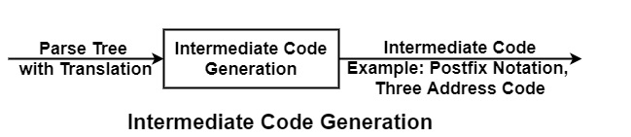

If it can divide the compiler stages into two parts, i.e., Front end & Back end, then this phase comes in between.

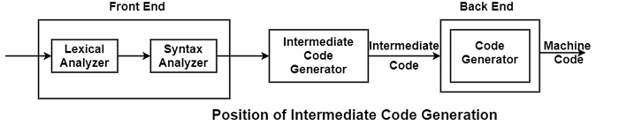

Example of Intermediate Code Generation

* Three Address Code− These are statements of form c = a op b, i.e., in which there will be at most three addresses, i.e., two for operands & one for Result. Each instruction has at most one operator on the right-hand side.

Example of three address code for the statement

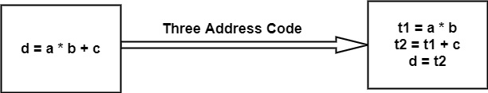

* Postfix Notation − In postfix notation, the operator comes after an operand, i.e., the operator follows an operand.

Example

* Postfix Notation for the expression (a+b) * (c+d) is ab + cd +*
* Postfix Notation for the expression (a*b) - (c+d) is ab* + cd + - .
* Syntax Trees − It is condensed form of parse tree in which leaves are identifiers and interior node will be operators.

Example

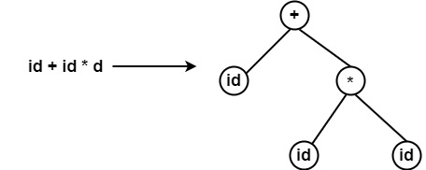

* Quadruples representation − Records with fields for the operators and operands can be used to describe three address statements. It is applicable to use a record structure with fields, first hold the operator ‘op’, next two hold operands 1 and 2 respectively, and the last one holds the result. This representation of three addresses is called a quadruple representation.
* Triples representation − The contents of operand 1, operand 2, and result fields are generally pointer to symbol records for the names defined by these fields. Therefore, it is important to introduce temporary names into the symbol table as they are generated.

This can be prevented by using the position of statement defines temporary values. If this is completed then, a record structure with three fields is enough to define the three address statements− The first holds the operator and the next two holds the values of operand 1 and operand 2 respectively. Such representation is called triple representation.

Advantages of Intermediate Code Generation

* It is Machine Independent. It can be executed on different platforms.
* It creates the function of code optimization easy. A machine-independent code optimizer can be used to intermediate code to optimize code generation.
* It can perform efficient code generation.
* From the existing front end, a new compiler for a given back end can be generated.
* Syntax-directed translation implements the intermediate code generation, thus by augmenting the parser, it can be folded into the parsing

The intermediate code generation phase typically involves the following steps:

1. Lexical and Syntax Analysis: The source code is first analyzed to break it down into tokens and create a parse tree or an abstract syntax tree (AST). This step involves lexical analysis, which converts the source code into tokens, and syntax analysis, which determines the structure and relationships between the tokens.
2. Semantic Analysis: The compiler performs semantic analysis on the parse tree or AST to check for any semantic errors, enforce language rules, and build a symbol table that keeps track of identifiers, their types, and their scopes. Semantic analysis ensures that the code is well-formed and meaningful according to the language's semantics.
3. Type Checking: The compiler performs type checking to verify that the operations and expressions in the code are compatible with the types of the involved variables, functions, and literals. Type checking ensures type safety and helps detect potential type-related errors.
4. Intermediate Code Generation: Based on the analyzed and validated parse tree or AST, the compiler generates intermediate code statements that represent the operations and constructs in the source code. The form of intermediate code can vary depending on the compiler and the chosen intermediate representation. Common intermediate representations include three-address code, abstract stack machines, and bytecode.
5. Optimization: Depending on the design of the compiler, certain optimization techniques may be applied to the generated intermediate code. These optimizations aim to improve the performance, efficiency, or maintainability of the resulting machine code. Optimization techniques can range from simple peephole optimizations to more complex algorithms such as loop optimization and data flow analysis.

The generated intermediate code serves as an intermediate representation that can be further processed and transformed before generating the final machine code. It provides a more manageable and uniform representation of the code, enabling subsequent optimization and target code generation phases.

Once the intermediate code is generated, it can be subjected to additional optimization passes, such as loop optimization, constant folding, and register allocation. Finally, the optimized intermediate code is translated into the target machine code specific to the hardware platform on which the program will be executed.

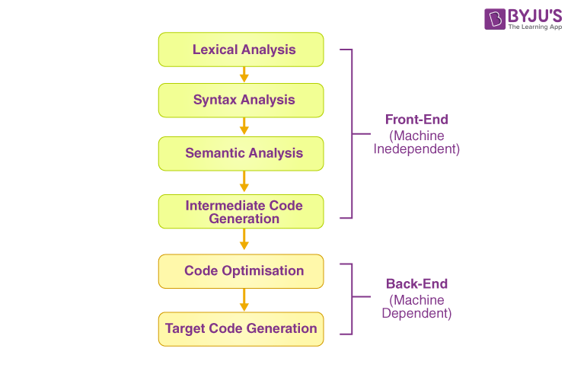

INTERMEDIATE CODE GENRATION IN COMPILE DESGIN

**Intermediate code**

Intermediate code refers to an abstract representation of a program that is generated during the compilation process. It serves as a middle-level representation between the high-level source code and the low-level machine code.**The** purpose of intermediate code is to provide a simplified and platform-independent representation of the program, which can be further processed and translated into machine code for execution. It captures the essential semantics of the source code while abstracting away specific details of the target hardware.

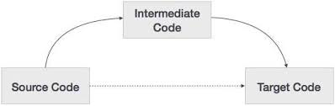

Intermediate code has several benefits in the compilation process:

1. Portability: Since intermediate code is not tied to a specific hardware platform, it can be easily translated to machine code for different architectures. This allows for cross-platform development and deployment of software.
2. Optimization: Intermediate code provides a convenient level of abstraction for performing various optimization techniques. Compilers can analyze the intermediate code and apply optimizations to improve the program's efficiency, speed, and resource usage.
3. Separation of Concerns: By generating an intermediate representation, compilers can separate the concerns of parsing, semantic analysis, and code generation. This modular approach makes the compilation process more manageable and facilitates code maintenance and enhancement.
4. Language Interoperability: Intermediate code can act as a bridge between different programming languages. It enables interoperability between languages by providing a common representation that can be understood and translated by multiple language compilers or interpreters.
5. Code Generation Efficiency: By working with an intermediate representation, compilers can apply advanced algorithms and techniques that optimize the translation to machine code. This can result in more efficient and optimized machine code generation.

**three address code**

Three-address code is an intermediate representation used in compiler design and optimization. It provides a structured and simplified representation of code that is closer to the machine code level than high-level source code. Three-address code is named as such because each instruction typically contains up to three operands.

**In** three-address code, instructions are designed to perform specific operations and manipulate data. Each instruction consists of three components:

1. Operation: It represents the specific operation to be performed, such as addition, subtraction, multiplication, assignment, etc. Examples of operations include "add," "sub," "mul," "assign," etc.
2. Left Operand: It represents the first operand involved in the operation. It can be a variable, constant, or an intermediate result from a previous instruction.
3. Right Operands: They represent the second and third operands involved in the operation. Like the left operand, they can be variables, constants, or intermediate results.

The general form of a three-address code instruction is:

* result := left_operand operation right_operand

Here, result is the variable or intermediate result where the output of the operation is stored. The left_operand and right_operand represent the inputs to the operation, and the operation specifies the computation to be performed.

For example, consider the following high-level code snippet:

* a = b + c * d;

This code can be translated to three-address code as follows:

* t1 := c * d
* t2 := b + t1
* a := t2

In the above three-address code, t1 and t2 are temporary variables used to store intermediate results during computation. The multiplication of c and d is stored in t1, then b is added to t1 and stored in t2, and finally, t2 is assigned to a.

Three-address code provides a simple and uniform representation that can be easily processed and optimized by the compiler. It allows for efficient analysis, transformation, and code generation stages in the compilation process. It also serves as a convenient target for various optimization techniques such as common subexpression elimination, constant folding, and register allocation.

**quadruples, triples, indirect triples**

Quadruples, triples, and indirect triples are different types of intermediate representations used in compiler design. They are structured formats that capture the essential semantics of the source code in a simplified manner.

1. Quadruples: Quadruples are a type of intermediate representation that uses four fields to represent each instruction. The four fields typically include an operator, two operands, and a result. Quadruples are often used in code generation and optimization phases of a compiler. Each quadruple corresponds to a single executable instruction in the target machine code.

Here is an example of a quadruple representing SQL, the addition operation:

* (ADD, operand1, operand2, result)

The above quadruple instructs the compiler to perform the addition of operand1 and operand2 and store the result in result.

1. Triples: Triples are a simplified form of intermediate representation that use three fields to represent each instruction. The three fields typically include an operator and two operands. Triples are commonly used in the early stages of code generation and optimization.

Here is an example of a triple representing the addition operation:

* (ADD, operand1, operand2)

The above triple instructs the compiler to add operand1 and operand2 without explicitly specifying the result.

1. Indirect Triples: Indirect triples, also known as quadruples with indirect addressing, are a variation of quadruples that include an additional field for addressing mode or memory location. They are used when the operands or results of an instruction are memory locations rather than explicit values.

Here is an example of an indirect triple:

* (ADD, operand1, operand2, result_address)

In the above indirect triple, operand1 and operand2 are memory locations, and result_address is the memory location where the result of the addition should be stored. **The** choice of using quadruples, triples, or indirect triples depends on the specific requirements of the compiler and the level of detail needed in the intermediate representation. Quadruples provide a more explicit representation of instructions, while triples and indirect triples offer a more compact representation with fewer fields. These intermediate representations play a crucial role in the translation and optimization of code during the compilation process.

**Directed acyclic graph.**

In the context of intermediate code generation, a directed acyclic graph (DAG) can be used as a data structure to represent the computations and dependencies present in the source code. The DAG serves as an intermediate representation of the code that captures the relationships between operations and variables.

During the intermediate code generation phase, the compiler constructs a DAG by analyzing the source code and identifying common subexpressions and shared computations. The DAG represents the expression or computation as a graph, where nodes represent operations or variables, and edges represent dependencies or data flow between them.

Here's how a DAG can be utilized in intermediate code generation:

1. Expression Evaluation: When generating intermediate code for expressions, the compiler can construct a DAG to represent the subexpressions and their relationships. Each node in the DAG represents an operation or variable, and the edges represent dependencies between them. By identifying common subexpressions and sharing their computations, the DAG can reduce redundant operations and improve code efficiency.
2. Common Subexpression Elimination: The DAG can help identify common subexpressions in the code. By traversing the DAG, the compiler can identify duplicate computations and replace them with a single instance. This optimization technique, known as common subexpression elimination, reduces redundant computations and improves the overall performance of the generated code.
3. Code Generation from DAG: Once the DAG is constructed and optimized, the compiler can generate intermediate code from the DAG representation. The code generation process involves traversing the DAG, mapping each node to the corresponding intermediate code instruction, and considering the dependencies between nodes to ensure the correct order of operations.

**EXAMPLE = 1**

T1 = a + b        
T2 = T1 + c       
T3 = T1 x T2

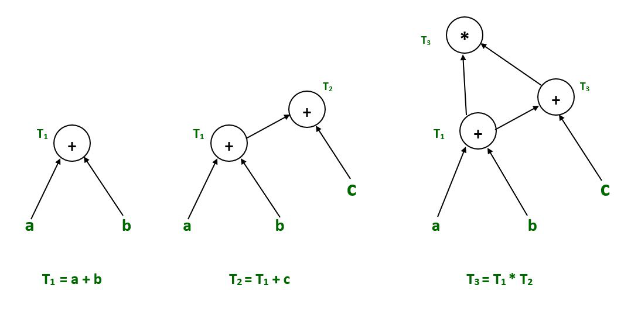

**EXAMPLE = 2**

**T1 = a + b  
T2 = a – b  
T3 = T1 * T2  
T4 = T1 – T3  
T5 = T4 + T3**

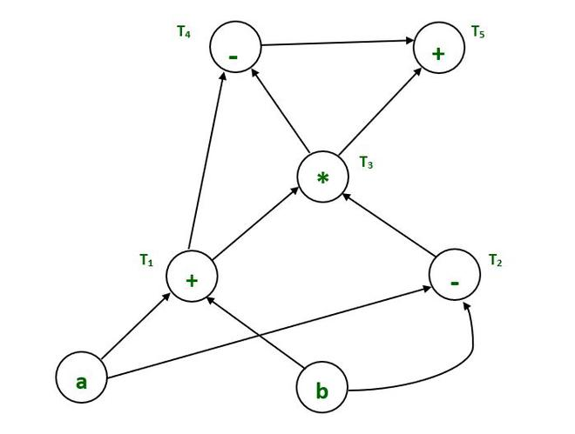

**Final Directed acyclic graph**

**Code Optimization:**

Code optimization is a crucial phase in the compilation process where the generated code is analyzed and transformed to improve its efficiency, performance, and resource utilization. The goal of code optimization is to produce code that executes faster, consumes less memory, and makes better use of system resources, while preserving the program's functionality.

Code optimization techniques can vary depending on the target architecture, programming language, and specific optimization goals. Here are some commonly used code optimization techniques:

1. Constant Folding: Evaluating constant expressions at compile-time and replacing them with their computed results. This eliminates unnecessary runtime computations.
2. Common Subexpression Elimination: Identifying and eliminating redundant computations by reusing previously computed values. This reduces the number of repeated calculations.
3. Dead Code Elimination: Identifying and removing code that does not contribute to the program's final output. This includes unused variables, unreachable code, and redundant statements.
4. Loop Optimization: Optimizing loops to reduce the number of iterations or improve memory access patterns. Techniques include loop unrolling, loop fusion, loop interchange, and loop-invariant code motion.
5. Data Flow Analysis: Analyzing how data flows through the program to identify opportunities for optimization. This includes techniques such as constant propagation, copy propagation, and reaching definitions analysis.
6. Register Allocation: Efficiently assigning variables and temporary values to CPU registers to minimize memory access and improve performance. Techniques like graph coloring and linear scan are commonly used for register allocation.
7. Inline Expansion: Replacing function calls with the actual function code to avoid the overhead of the function call and return. This improves performance by reducing the function call overhead.
8. Code Reordering: Rearranging code instructions to optimize cache utilization and improve instruction pipeline efficiency. This includes techniques like code motion and loop interchange.
9. Vectorization: Transforming scalar code into SIMD (Single Instruction, Multiple Data) instructions to take advantage of parallelism and improve performance on vector architectures.
10. Profiling-Guided Optimization: Using runtime profiling information to guide optimizations, such as identifying hotspots and selectively optimizing critical code sections.

Code optimization is an iterative process, and different combinations of optimization techniques can be applied based on the specific requirements and constraints of the program and target architecture.

**Common sub expression elimination**

Common subexpression elimination (CSE) is an optimization technique that aims to eliminate redundant computations by identifying and reusing common subexpressions within a program. The goal is to avoid recomputing the same value multiple times when it can be computed once and reused.

Here's how common subexpression elimination works:

1. Identification of Common Subexpressions: The compiler analyzes the code to identify subexpressions that occur multiple times within the program. A subexpression is a portion of code that can be evaluated independently and has no side effects.
2. Creation of a Symbolic Table: The compiler maintains a symbolic table or a hash table that maps the subexpressions to their computed results. Each subexpression is assigned a unique symbol, and its computed value is associated with that symbol.
3. Subexpression Evaluation: As the compiler traverses the code, it checks if a subexpression has already been computed and stored in the symbolic table. If it finds a match, it replaces subsequent occurrences of the subexpression with the symbol representing the previously computed value.
4. Insertion of Temporary Variables: In some cases, when a subexpression is shared across multiple branches or scopes, the compiler may introduce temporary variables to store the computed result. The temporary variable is assigned the value of the subexpression, and subsequent references to the subexpression are replaced with the temporary variable.

The benefits of common subexpression elimination include:

* Reducing redundant computations: By eliminating redundant calculations, the overall execution time of the program can be reduced.
* Improving code size: The removal of duplicate subexpressions can lead to smaller executable code, resulting in better memory utilization and cache performance.
* Simplifying code analysis: With fewer redundant computations, the complexity of data flow analysis and other optimization techniques can be reduced, enabling more efficient optimization passes.

However, it's important to note that common subexpression elimination may have limitations:

* Side effects: CSE is applicable only to subexpressions without side effects. If a subexpression has side effects, such as modifying variables or invoking functions, it cannot be eliminated.
* Dependencies: CSE requires careful consideration of dependencies among expressions. If modifying the order of computations affects the program's behavior, CSE should be applied cautiously.
* Increased register pressure: Introducing temporary variables may increase register pressure, potentially impacting register allocation and overall performance. Proper management of temporary variables is crucial.

**copy propagation**

Copy propagation is an optimization technique that aims to eliminate unnecessary variable assignments by replacing uses of a variable with its assigned value. The goal is to reduce memory access and improve the efficiency of the code by minimizing the number of unnecessary variable copies.



Here's how copy propagation works:

1. Identify Copy Assignments: The first step is to identify assignments of the form x = y, where y is a variable or expression. These assignments indicate that the value of y is copied into x.
2. Propagate Copies: After identifying the copy assignments, the compiler replaces subsequent uses of x with y. This means that any occurrence of x in subsequent code is replaced with y, as long as the value of y has not been modified since the copy assignment.
3. Tracking Modifications: The compiler needs to track modifications to y after the copy assignment. If y is modified, copy propagation cannot be performed as it would yield incorrect results.

Copy propagation offers several benefits:

* Elimination of Redundant Copies: By replacing variables with their assigned values, unnecessary memory accesses and assignments can be eliminated. This reduces memory traffic and improves code efficiency.
* Improved Constant Folding: Copy propagation can enable better constant folding, where the compiler evaluates and replaces expressions with their constant values at compile-time. By propagating copies of constants, the compiler can fold more expressions and optimize the code further.
* Simplification of Code: Copy propagation simplifies the code by reducing the number of variables and assignments. This can improve code readability and make it easier to analyze and optimize.

However, copy propagation has some limitations:

* Aliasing: If there is aliasing between variables, where multiple variables refer to the same memory location, copy propagation can lead to incorrect results. It is essential to ensure that the values being propagated are not modified or accessed through different aliases.
* Side Effects: Copy propagation should not be performed on variables with side effects, such as those modified in function calls or used in I/O operations. It is crucial to consider the behavior and side effects of the variables involved.

**Dead code elimination :**  is an optimization technique that aims to identify and remove portions of code that are not reachable or do not contribute to the final output of the program. Dead code refers to code that has no effect on the program's behavior or produces no useful result.

Here's how dead code elimination works:

1. Reachability Analysis: The compiler performs a reachability analysis starting from the entry point of the program. It identifies all the code that is reachable from the entry point by traversing the control flow graph.
2. Dead Code Identification: Code that is determined to be unreachable or has no impact on the program's output is considered dead code. This includes code that follows unconditional branches, code after return statements or exception throws, and code that assigns values to variables that are never used.
3. Dead Code Removal: Once dead code is identified, the compiler eliminates it from the codebase. This removal can be done during the intermediate code generation or optimization phase.

Benefits of dead code elimination include:

* Improved Performance: Dead code elimination reduces the amount of code to be executed, resulting in faster execution time and improved performance.
* Code Size Reduction: Removing dead code reduces the size of the compiled executable, saving memory and storage space.
* Simplified Code Analysis: With dead code removed, subsequent analysis and optimization passes can operate on a smaller and more manageable codebase, leading to more efficient optimizations.

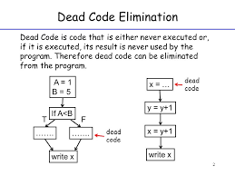

It's important to note that dead code elimination should be performed with caution, as incorrect identification of dead code can lead to unintended behavior. Some considerations and limitations include:

* Dynamic Behavior: Dead code elimination is based on static analysis and may not handle dynamic behaviors, such as code that is conditionally executed based on runtime input.
* Side Effects: Code with side effects, such as I/O operations or function calls with observable effects, should not be eliminated even if they are not directly used. The elimination of such code could alter the program's behavior.
* External Dependencies: Code that interacts with external systems or APIs may have side effects or hidden dependencies that need to be considered before elimination.

**constant folding**

Constant folding is an optimization technique that involves evaluating constant expressions at compile-time rather than at runtime. The goal is to replace constant expressions with their computed values, reducing the need for runtime computations and improving the efficiency of the code.

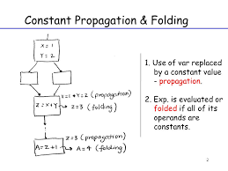

Here's how constant folding works:

1. Identify Constant Expressions: The compiler analyzes the code and identifies expressions where all operands are constants. These expressions involve only literal values or variables that have constant values assigned to them.
2. Evaluate Expressions: After identifying constant expressions, the compiler performs the computation and evaluates the expression at compile-time. This can involve simple arithmetic operations, logical operations, comparisons, or other supported operations.
3. Replace with Computed Values: The compiler replaces the constant expressions with their computed values. This substitution is performed during the intermediate code generation or optimization phase.

Benefits of constant folding include:

* Elimination of Redundant Computations: By evaluating constant expressions at compile-time, constant folding eliminates the need for runtime computations, reducing the overhead associated with repeatedly computing the same expression.
* Improved Efficiency: Constant folding can lead to more efficient code execution by reducing the number of operations performed at runtime.
* Code Size Reduction: Replacing constant expressions with their computed values reduces the size of the compiled executable, saving memory and storage space.

It's important to note the limitations and considerations of constant folding:

* Side Effects: Constant folding can only be applied to expressions without side effects. Expressions involving functions with observable side effects or I/O operations should not be subject to constant folding.
* Data Dependencies: Constant folding assumes that the values involved in the expression remain constant throughout the program's execution. If there are dependencies or modifications to the operands, constant folding may yield incorrect results.
* Precision and Overflow: The computed values may differ from the runtime results if there are precision differences or potential overflow/underflow issues between the compile-time and runtime environments.

**strength reduction**

Strength reduction is an optimization technique that replaces expensive or complex operations with simpler and more efficient alternatives. It aims to improve the efficiency of code by reducing the computational overhead associated with certain operations.

The key idea behind strength reduction is to replace computationally expensive operations with less expensive operations that achieve the same or equivalent results. This optimization technique is particularly effective when applied to operations involving arithmetic calculations or loop constructs.

Here are a few common scenarios where strength reduction can be applied:

1. Multiplication to Addition: Multiplication operations can be replaced with addition operations if the multiplicand is a power of 2. For example, replacing the multiplication by 8 with three additions of the multiplicand (e.g., x * 8 becomes x + x + x) can be more efficient, as addition is typically faster than multiplication.
2. Division to Multiplication or Bit Shifting: Division operations can be replaced with multiplication operations or bit shifting operations if the divisor is a power of 2. For example, replacing the division by 4 with a right shift by 2 (e.g., x / 4 becomes x >> 2) can be more efficient.
3. Loop Strength Reduction: In loops, operations that remain constant across iterations can be moved outside the loop to reduce redundant computations. For instance, if a loop performs the same computation on a loop invariant value in every iteration, the computation can be moved outside the loop.
4. Function Inlining: Replacing function calls with the actual function body can eliminate the overhead associated with function call and return. Inlining is a form of strength reduction that reduces the function call overhead.

**loop optimization**

Loop optimization is a crucial category of optimizations specifically targeting loops in a program. Loops are often performance-critical sections of code, and optimizing them can significantly improve the overall efficiency and execution speed of the program. Loop optimization techniques aim to minimize loop overhead, reduce redundant computations, and improve memory access patterns.

Here are some common loop optimization techniques:

1. Loop Unrolling: Loop unrolling involves duplicating loop iterations to reduce the overhead of loop control instructions, such as loop condition checks and loop variable updates. By processing multiple loop iterations in each iteration, loop unrolling can exploit instruction-level parallelism and reduce branch instructions.
2. Loop Fusion: Loop fusion combines multiple loops that operate on the same data sets into a single loop. This reduces the loop overhead and improves memory locality by avoiding redundant traversals of the same data.
3. Loop Blocking or Loop Tiling: Loop blocking divides a large loop into smaller blocks to improve cache utilization and reduce memory access latency. By processing a smaller block of data at a time, loop blocking can improve cache locality and reduce the number of cache misses.
4. Loop Interchange: Loop interchange reorders nested loops to improve memory access patterns and exploit better data locality. It can change the order of nested loops to match the order of memory access, reducing cache misses and improving performance.
5. Loop Invariant Code Motion: Loop invariant code motion identifies expressions or computations that remain constant across loop iterations and moves them outside the loop. This reduces redundant computations and improves efficiency.
6. Loop Vectorization: Loop vectorization transforms scalar code into SIMD (Single Instruction, Multiple Data) instructions, exploiting parallelism and improving performance on vector architectures. It involves rewriting the loop to process multiple data elements simultaneously using vector instructions.
7. Loop Parallelization: Loop parallelization aims to execute loop iterations concurrently by distributing the work among multiple threads or processors. Parallelization techniques like OpenMP or SIMD instructions can be applied to exploit multi-core architectures.
8. Loop Peeling: Loop peeling is a technique that handles special cases or edge conditions separately from the main loop to reduce branch instructions or improve performance in specific cases.

These techniques are not mutually exclusive, and combinations of them can be applied to achieve better optimization results. The choice of which techniques to apply depends on the specific characteristics of the loop, the target architecture, and the trade-offs between code complexity and performance improvements.

**Code Generation: Basic blocks & flow graphs**

Code generation is the process of translating an intermediate representation (such as an abstract syntax tree or three-address code) into executable machine code. Two important concepts in code generation are basic blocks and flow graphs, which help organize and represent the control flow of the program.

1. Basic Blocks: Basic blocks are contiguous sequences of instructions in a program that have a single entry point and a single exit point. They are constructed such that control flow enters at the beginning of the block and continues sequentially until it reaches the end of the block or encounters a control transfer instruction (e.g., jump or branch). Basic blocks are typically identified during the control flow analysis phase of compilation.
2. Flow Graphs: A flow graph, also known as a control flow graph, is a directed graph that represents the control flow of a program. It consists of basic blocks as nodes and control flow edges that connect the basic blocks based on the program's control transfer instructions. The edges indicate the possible paths that control flow can take during program execution.

In a flow graph, the basic blocks represent individual units of code with well-defined control flow behavior, and the edges between them indicate the potential execution paths between those blocks. The flow graph provides a visual representation of the program's control flow structure, enabling various code analysis and optimization techniques.

Here's an example to illustrate basic blocks and flow graphs:

The flow graph for this code snippet would consist of two nodes representing the basic blocks, with an edge connecting Basic Block 1 to Basic Block 2. The edge indicates the control flow from the end of Basic Block 1 to the beginning of Basic Block 2.

Flow Graph:

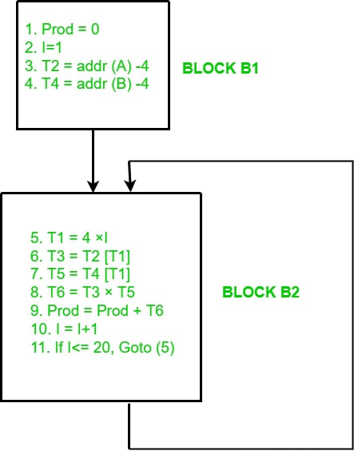

Consider the following code snippet:

**int sum(int a, int b) {**

**int result = a + b;**

**return result;**

**}**

In this example, the code can be divided into two basic blocks:

**Basic Block 1:**

**int result = a + b;**

**Basic Block 2:**

**return result;**

Flow graphs provide a foundation for performing various code analysis and optimization techniques, such as data flow analysis, loop optimization, and register allocation. They help visualize the control flow structure of the program and enable the compiler to make informed decisions during the code generation process.

**Peephole optimization**

Peephole optimization is a local and pattern-based optimization technique that focuses on improving code efficiency by examining and transforming a small window or "peephole" of instructions in a program. It involves identifying specific patterns of instructions and replacing them with more efficient or optimized sequences.

The name "peephole" refers to the small window or sequence of consecutive instructions that are considered for optimization. Typically, peephole optimizations work on a fixed-size window of instructions, examining a limited number of instructions before and after the current instruction.

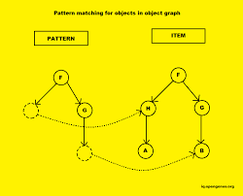

Here are some common peephole optimization techniques:

1. Constant Folding: Detecting and evaluating constant expressions at compile-time rather than performing the computation at runtime. For example, replacing x = 2 + 3 with x = 5.
2. Copy Propagation: Replacing uses of a variable with its assigned value, eliminating unnecessary assignments. For example, replacing x = y; z = x; with z = y;.
3. Strength Reduction: Replacing expensive operations with simpler alternatives. For instance, replacing multiplication with addition if the multiplicand is a power of 2.
4. Dead Code Elimination: Removing instructions that have no effect on the program's output. This includes unused assignments, unreachable code, and redundant computations.
5. Instruction Combination: Replacing a sequence of instructions with a more efficient or optimized instruction. For example, replacing multiple load-store instructions with a single load-store instruction or using specific CPU instructions that perform multiple operations in a single instruction.
6. Peephole Register Allocation: Optimizing register allocation by examining the use and reuse of registers within the peephole window. This can involve eliminating unnecessary register spills and reloads or reordering instructions to minimize register pressure.

Peephole optimizations are typically applied iteratively over multiple passes, scanning the code for specific patterns and making local modifications to improve efficiency. While each peephole optimization is relatively simple, their cumulative effect can lead to noticeable performance improvements in the generated code.